**WEB DEVELOPMENT INTERNSHIP**

**WEEK #2**

**Task#1:-**

**Create a complex layout using CSS Grid.**

**HTML FILE:-**

<!DOCTYPE html>

<html lang="en">

<head>

  <meta charset="UTF-8" />

  <meta name="viewport" content="width=device-width, initial-scale=1.0" />

  <title>CSS Grid Layout Demo</title>

  <link rel="stylesheet" href="grid.css" />

</head>

<body>

  <div class="grid-container">

    <header>Header</header>

    <nav>Navigation</nav>

    <main>Main Content</main>

    <aside>Sidebar</aside>

    <footer>Footer</footer>

  </div>

</body>

</html>

**CSS FILE:-**

.grid-container {

  display: grid;

  grid-template-areas:

    "header header"

    "nav nav"

    "main aside"

    "footer footer";

  grid-template-columns: 3fr 1fr;

  gap: 15px;

  padding: 20px;

}

header { grid-area: header; background: #333; color: white; padding: 10px; }

nav { grid-area: nav; background: #555; color: white; padding: 10px; }

main { grid-area: main; background: #ddd; padding: 10px; }

aside { grid-area: aside; background: #eee; padding: 10px; }

footer { grid-area: footer; background: #333; color: white; padding: 10px; }

**OUTPUT:-**

**TAS**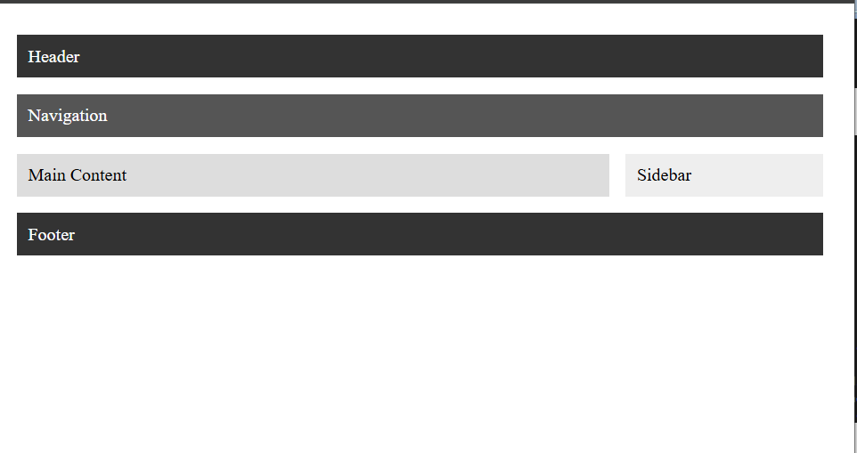

**Task#2:-**

**Design a responsive navbar with dropdowns.**

**HTML FILE:-**

<!DOCTYPE html>

<html lang="en">

<head>

  <meta charset="UTF-8" />

  <meta name="viewport" content="width=device-width, initial-scale=1.0"/>

  <title>Navbar with Dropdown</title>

  <link rel="stylesheet" href="navbar.css" />

</head>

<body>

  <nav class="navbar">

  <div class="nav-container">

    <div class="logo">MySite</div>

    <div class="menu-toggle" id="menu-toggle">☰</div>

    <ul class="nav-links" id="nav-links">

      <li><a href="#">Home</a></li>

      <li class="dropdown">

        <a href="#">Projects ▾</a>

        <ul class="dropdown-menu">

          <li><a href="#">Web Design</a></li>

          <li><a href="#">UI/UX</a></li>

        </ul>

      </li>

      <li><a href="#">About</a></li>

    </ul>

  </div>

</nav>

</body>

</html>

**CSS FILE:-**

/* Navbar Improved */

.navbar {

  grid-area: nav;

  background: #2c3e50;

  color: white;

}

.nav-container {

  display: flex;

  justify-content: space-between;

  align-items: center;

  padding: 14px 20px;

}

.logo {

  font-size: 1.5rem;

  font-weight: bold;

}

.menu-toggle {

  display: none;

  font-size: 1.5rem;

  cursor: pointer;

  color: white;

}

/* Nav Links */

.nav-links {

  display: flex;

  list-style: none;

  gap: 20px;

}

.nav-links li {

  position: relative;

}

.nav-links a {

  color: white;

  text-decoration: none;

  padding: 10px;

  display: block;

}

/* Dropdown */

.dropdown-menu {

  display: none;

  position: absolute;

  top: 100%;

  background: #34495e;

  min-width: 150px;

  border-radius: 4px;

  z-index: 100;

}

.dropdown-menu li a {

  padding: 10px;

}

.dropdown:hover .dropdown-menu {

  display: block;

}

**OUTPUT:-**



**Task#3:-**

**Implement CSS animations and transitions.**

**HTML FILE:-**

<!DOCTYPE html>

<html lang="en">

<head>

  <meta charset="UTF-8" />

  <meta name="viewport" content="width=device-width, initial-scale=1.0"/>

  <title>Animations and Transitions</title>

  <link rel="stylesheet" href="animation.css" />

</head>

<body>

  <button class="animated-btn">Hover Me</button>

  <div class="animated-box">I Fade In</div>

</body>

</html>

**CSS FILE:**

.animated-btn {

  padding: 10px 20px;

  background: #28a745;

  color: white;

  border: none;

  transition: background 0.3s;

}

.animated-btn:hover {

  background: #218838;

}

.animated-box {

  margin-top: 30px;

  width: 200px;

  padding: 20px;

  background: #007bff;

  color: white;

  animation: fadeIn 2s ease-in-out;

}

@keyframes fadeIn {

  from { opacity: 0; transform: translateY(20px); }

  to { opacity: 1; transform: translateY(0); }

}

**Task#4:-**

**Create a responsive image gallery.**

**HTML FILE:-**

<!DOCTYPE html>

<html lang="en">

<head>

  <meta charset="UTF-8" />

  <meta name="viewport" content="width=device-width, initial-scale=1.0"/>

  <title>Image Gallery</title>

  <link rel="stylesheet" href="image.css" />

</head>

<body>

  <div class="gallery">

    <img src="pic.png" alt="Image 1" />

    <img src="pic2.png" alt="Image 2" />

    <img src="pic3.png" alt="Image 3" />

    <img src="pic4.png" alt="Image 4" />

  </div>

</body>

</html>

**CSS FILE:-**

**.gallery {**

  display: grid;

  grid-template-columns: repeat(auto-fit, minmax(200px, 1fr));

  gap: 15px;

  padding: 20px;

}

.gallery img {

  width: 100%;

  height: auto;

  border-radius: 8px;

  transition: transform 0.3s ease;

}

.gallery img:hover {

  transform: scale(1.05);

**Task#5:-**

**Use media queries for a mobile-friendly design.**

**HTML FILE:-**

<!DOCTYPE html>

<html lang="en">

<head>

  <meta charset="UTF-8" />

  <meta name="viewport" content="width=device-width, initial-scale=1.0"/>

  <title>Media Queries Demo</title>

  <link rel="stylesheet" href="query.css" />

</head>

<body>

  <div class="box">Resize the window to see the effect.</div></body></html>

**CSS FILE:-**

.box {

  background: lightcoral;

  color: white;

  padding: 20px;

  text-align: center;

  font-size: 1.5rem;

}

@media (max-width: 768px) {

  .box {

    background: steelblue;

    font-size: 1.2rem;

  }

}

@media (max-width: 480px) {

  .box {

    background: darkgreen;

    font-size: 1rem;

  }

}